WASHINGTON EVALUATORS 

**The Board of the Washington Evaluators (WE) invites you to join us for our**

***30th Anniversary Celebration***

**Wednesday, October 1, 2014: 5:30pm – 6:30pm**

**Cleveland Park Library**

**3310 Connecticut Ave NW, Washington, DC 20008**

***Followed by a Happy Hour at the Uptown Tap House***

[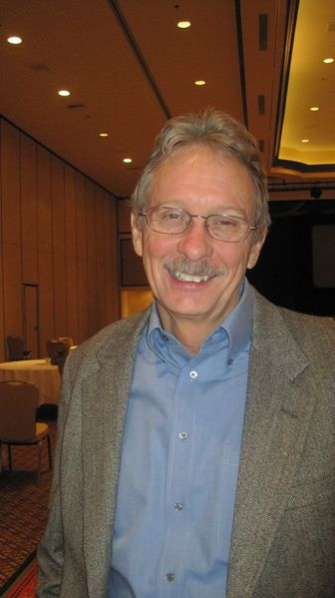](http://wiki.ilru.net/images/1/12/Mike_picture.JPG)

In 1984, Michael Hendricks, a Washington, DC based evaluation consultant, had a great idea. Mike was the president of Evaluation Network (ENet), one of two organizations (with the Evaluation Research Society) that in 1986 became the American Evaluation Association (AEA).

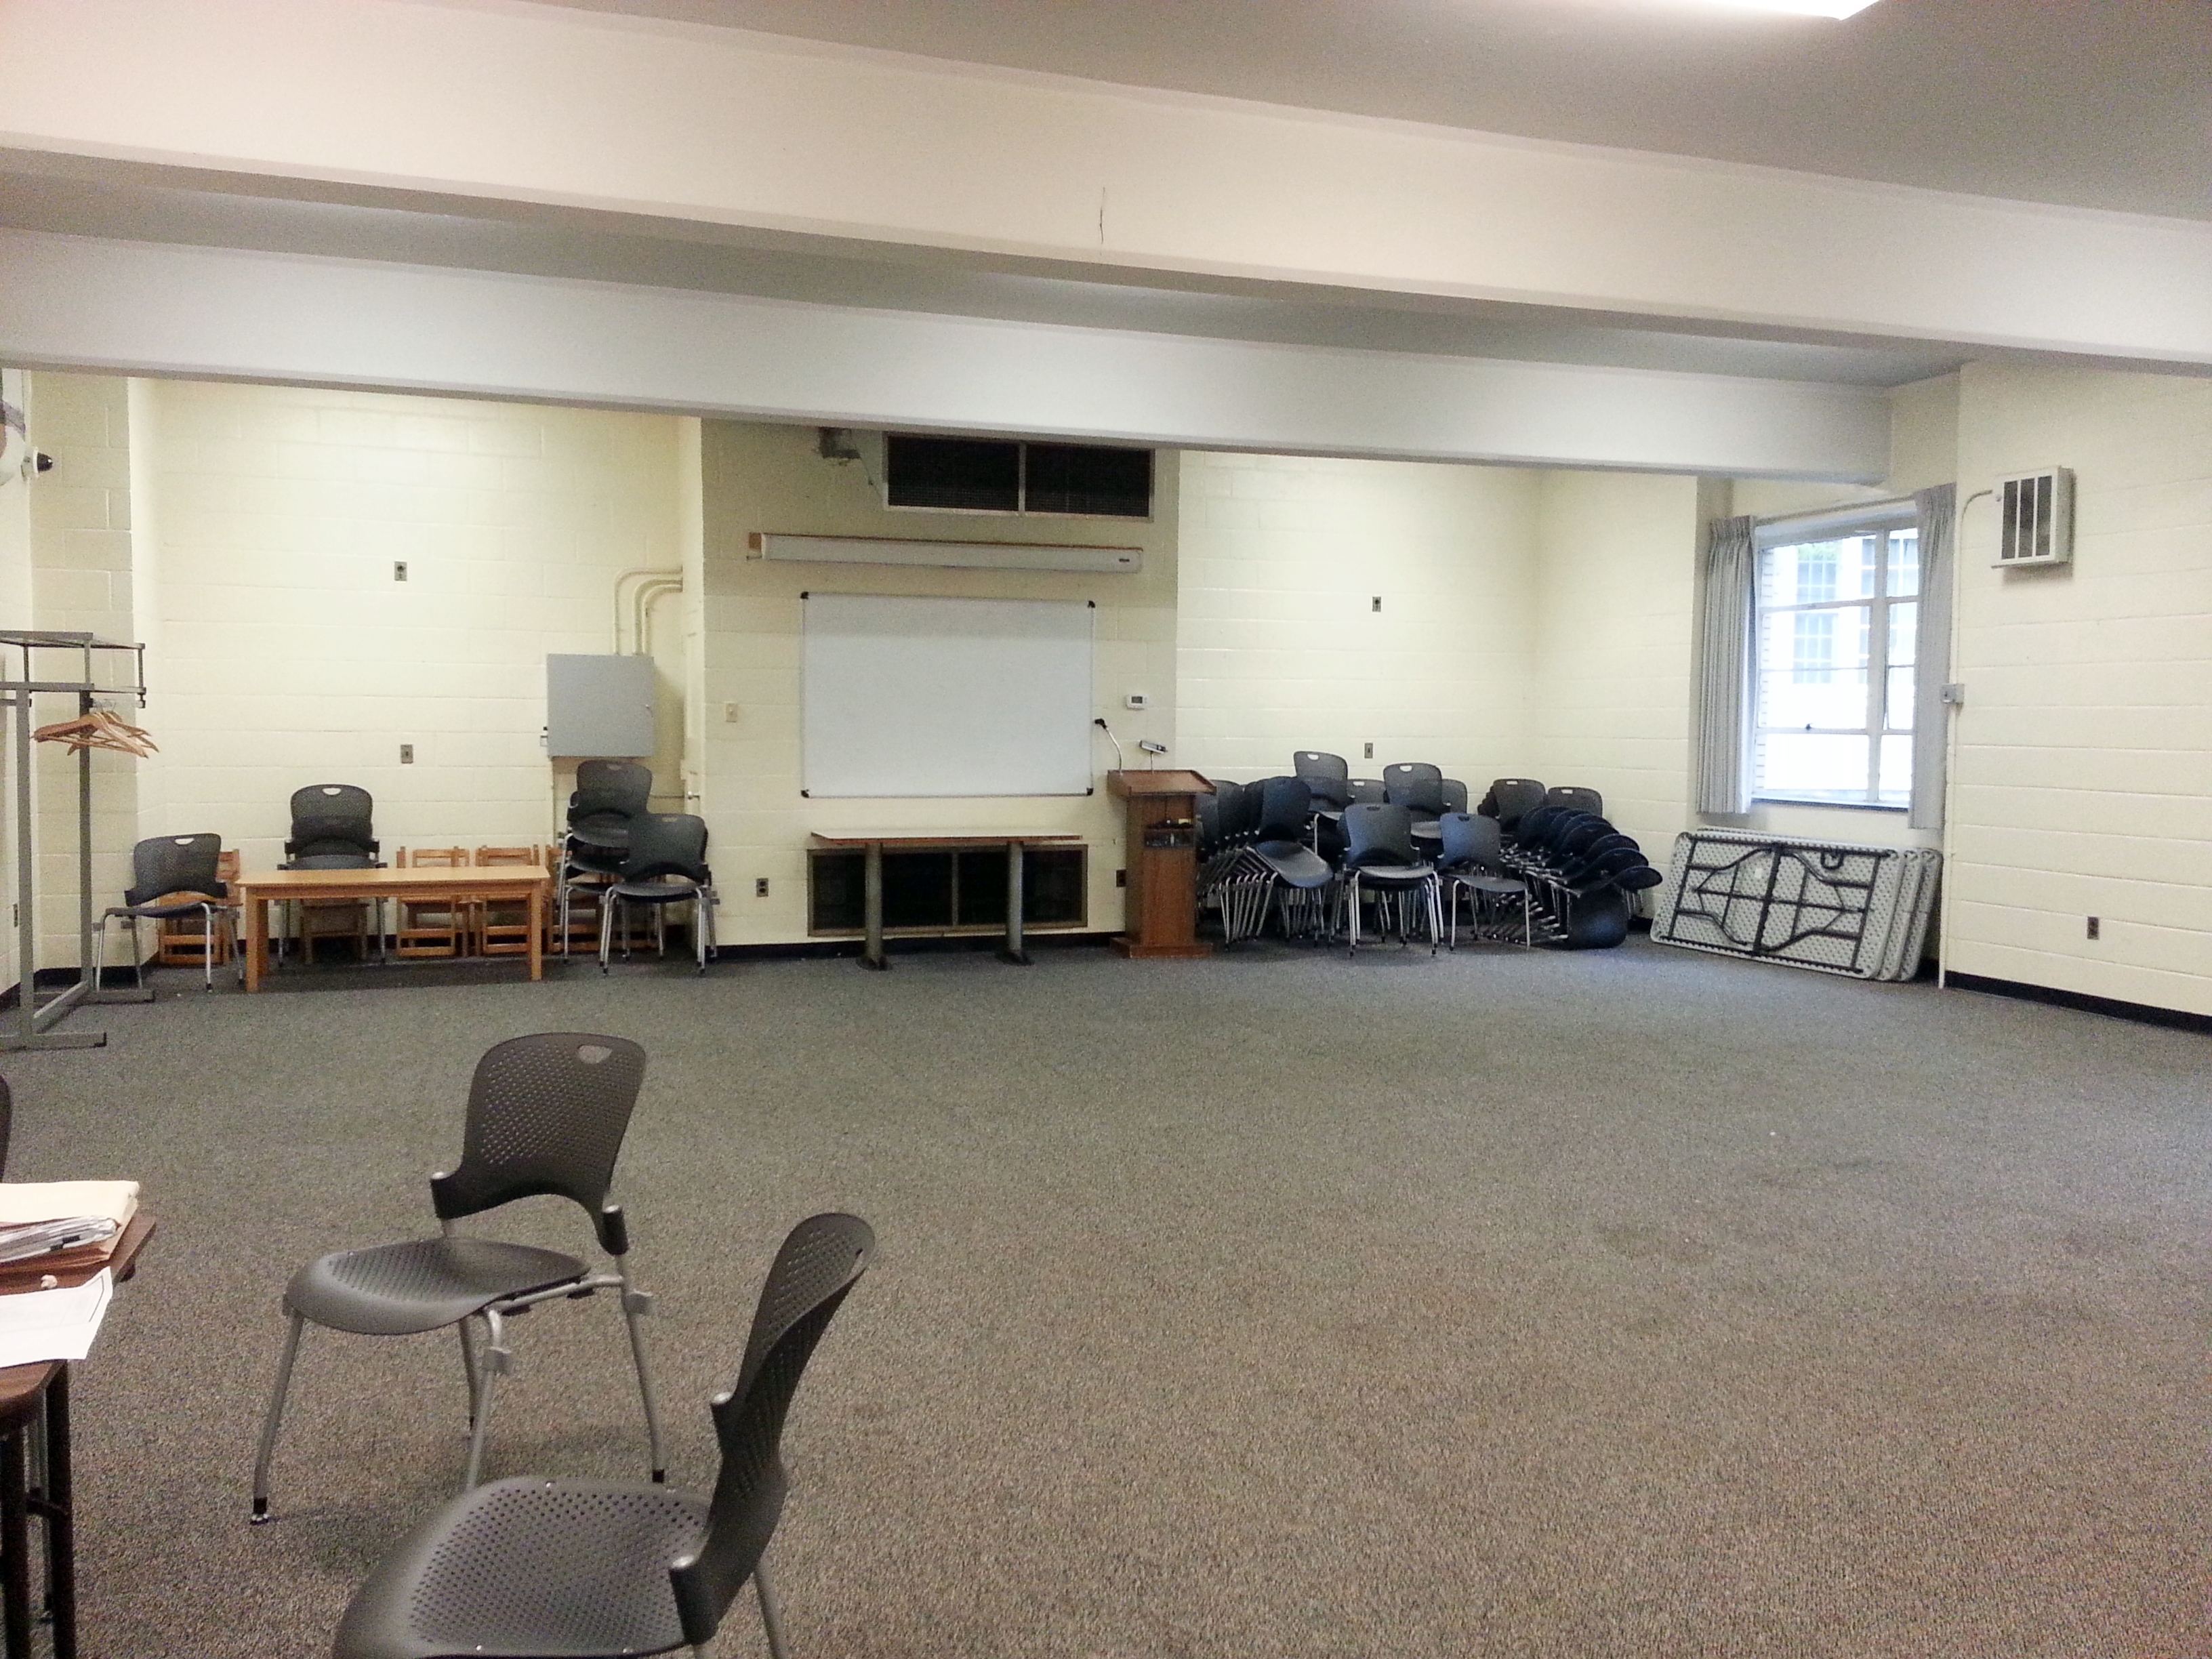Mike thought, “Why not organize an evaluation community in the Washington, DC area? WE was founded in 1984, and our first meeting was in September of that year. Twelve of us met in the community room of the Cleveland Park library.”

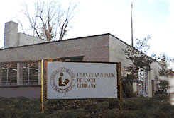To celebrate our 30th Anniversary, the Washington Evaluators will once again gather at the Cleveland Park Library. Former and current WE leaders will discuss how WE has evolved. Attendees are invited to participate in an open discussion: “*How can evaluation communities of practice address evaluation challenges and take advantage of opportunities to sustain evaluators and the evaluation profession?”* The results will be presented at a session at the 2014 AEA Conference!

After the celebration, join us two blocks north at the Uptown Tap House for light snacks and a cash bar with happy hour prices.

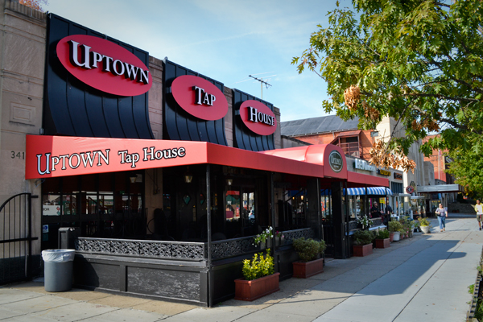

***WE 30th Anniversary Happy Hour***

**October 1, 2014: 6:30pm – 8:30pm**

**Uptown Tap House, 3412 Connecticut Ave NW,**

**Washington, DC 20008**

Please RSVP to <http://washingtonevaluators.org/events>.